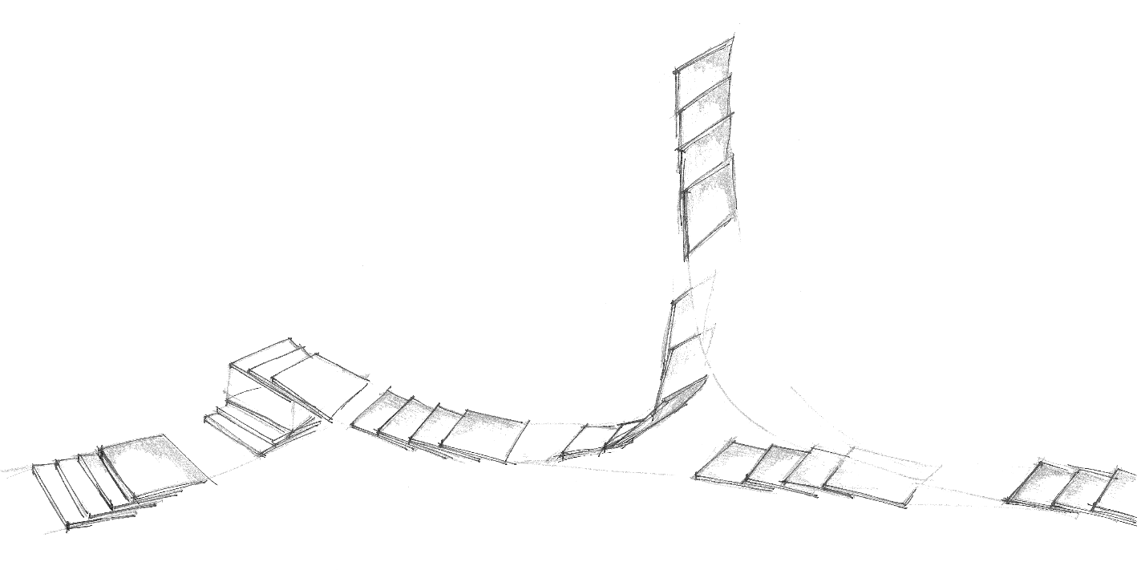

IP-MAC-AUT-FDS | Machine Name and Machine Version  Short machine description
IP-MAC-AUT-FDS | Functional Design Specification for Automation System
IP-MAC-AUT-FDS | Revision B  2021-02-16

Disclaimer
The information in this document is subject to change without notice and should not be interpreted as a commitment by IMPACK packaging (referred to as IMPACK in this document). While all reasonable care has been taken to ensure the accuracy of the content, IMPACK assumes no responsibility for any errors that may appear in this document.
Except as may be expressly stated anywhere in this manual, nothing herein shall be interpreted as any kind of guarantee or warranty by IMPACK for losses, damages to persons or property, fitness for a specific purpose or the like. All pertinent state, regional, and local safety regulations must be observed when installing and using the products or systems in this document.
In no event shall IMPACK be liable for incidental or consequential damages arising from use of this document, processes and products described herein. It is the duty of any such user or integrator to perform the appropriate and complete risk analysis, evaluation and testing of the products or systems with respect to the relevant specific application or use thereof.
This document and parts thereof must not be reproduced or copied without IMPACK's written permission.
When devices are used for applications with technical safety requirements, the relevant instructions must be followed.
The original language for this publication is English. Any other languages that are supplied have been translated from English.
© Copyright 2021 IMPACK. All rights reserved.

Document information

Authors
Name | Company | Function
Frédéric Boyadjian | Conception Impack | Concepteur Système Automatisé

Approvals
Approver | Company | Role in project | Version | Date
Frédéric Boyadjian | Impack Packaging | Project Director | A | 2021-02-16
Mathieu Tremblay | Impack Packaging | Steering Committee
Alexandre Bélanger | Impack Packaging | Steering Committee

<Examples of roles in project:

- Project director
- Project manager
- Project team members
- Project sponsor
- Project consultant
- Steering committee
- Business analysts
- Functional managers
- Resource managers
- Product testers
- End users
- Suppliers
- Contractors and subcontractors
- Government regulators
- Communities
- Investors or shareholders
- Employees
- Client or customer internal or external)>

Revision History
Revision | Date Description | Revision Content
A | 2021-02-16 | First Revision

Table of Contents

Document information 3
Authors 3
Approvals 3
Revision History 3
Table of Contents 4
1. Introduction 6
1.1 Purpose of the document 6
1.2 Risks and Assumptions 6
2. Machine Description 7
2.1 Purpose 7
2.2 Specifications 7
2.3 Schematics 7
2.3 Functional Decomposition 7
2.4 Limitations and Exclusions 7
2.4.1 Limitations 7
2.4.2 Exclusions 8
3. Security 9
3.1 User Groups 9
3.2 Users 9
3.3 User Levels Accesses 9
4. Operation Modes and Machine States 10
4.1 Operation mode 10
4.2 State Machine 10
5. Actions and Setpoints 11
5.1 Production 11
5.1.1 Setpoints 11
5.1.2 Actions 11
5.2 Manual 13
5.2.1 Setpoints 13
5.2.2 Actions 13
5.3 Maintenance 15
5.3.1 Setpoints 15
5.3.2 Actions 15
6. Events and Categories 17
6.1 Categories 17
6.2 Events 17
7. Recipes 18
7.1 Recipe Families 18
7.2 Recipe Groups 18
7.3 Recipe Ingredients 18
8. Metrics & KPIs 19
8.1 Metrics & KPIs 19
8.2 Shifts 19
9. Interfaces 20
9.1 Operator Interfaces 20
9.1.1 Signaling 20
9.1.2 Operator Interface Panels 21
9.3 Machine-to-Machine Interfaces 21
9.3.1 Physical interfaces 21
9.3.2 PackTags Interface 22
10. Reporting 25
11. Definitions and Abbreviations 26
12. References 27
13. Appendix 28
13.1 PackML Summary 28
13.2 PackML Base Structure Data Types 30
13.2.1 Alarm 30
13.2.2 Count 30
13.2.3 Descriptor 30
13.2.4 EquipmentInterlock 31
13.2.5 Ingredient 31
13.2.6 Interface 31
13.2.7 Product 31

1. Introduction

< Identify and describe the business need or problem this document will address. Include background information here.>

1.1 Purpose of the document
The Functional Specification Document is a document that provides detailed information on how the system solution will function and the requested behavior. This document is created based on PackML, a software programming methodology developed and maintained by OMAC (the Organization for Machine Automation and Control) and the ISA (the International Society of Automation) under ISA-TR88.00.02-2015. Included in this document will be the detailed functional design specifications of the machine including decomposition, modes and states, actions and events.

1.2 Risks and Assumptions
<List any assumed factors and identified risks that could affect the functional design of the system. Included can be third-party or commercial components that will be used, issues around the operating environment, or any constraints.>

2. Machine Description

2.1 Purpose
<Provide a short description of what problem the machine solves. including schematics, capabilities, performances, main component descriptions, objectives, and goals.>

2.2 Specifications

2.3 Schematics

2.3 Functional Decomposition
The machine representation decomposed in physical (Control Modules) and functional elements (Equipment Modules), based on standardized method described in the ISA S88.00.05 standard, also known as Make2Pack.

2.4 Limitations and Exclusions

2.4.1 Limitations
<List limitations of the system, things that the system is not able to do>

2.4.2 Exclusions
<List exclusions of the system, things that will not be implemented in the scope of the current project.>

3. Security

Security secures objects and screens from unauthorized access.

3.1 User Groups
User Group | Level | PLC | HMI | Safety Controller
Devs | 1 | ☒ | ☒ | ☒
Admins | 5 | ☐ | ☒ | ☐
Maintenance | 10 | ☒ | ☒ | ☐
Operators | 15 | ☐ | ☒ | ☐

3.2 Users
User | User Group | Login Name | Password
Admin1 | Admins | Admin1 | Admin1
Oper1 | Operators | Oper1 | Oper1
Maint1 | Maintenance | Maint1 | Maint1

3.3 User Levels Accesses
Level | Develop | Download | Maintenance | Operate | Edit Security | Edit Recipes
1 | ☐ | ☐ | ☐ | ☐ | ☐ | ☐
5 | ☐ | ☐ | ☐ | ☐ | ☐ | ☐
10 | ☐ | ☐ | ☐ | ☐ | ☐ | ☐

4. Operation Modes and Machine States

This machine implements the PackML machine modes and state model. PackML is a programming methodology that is organized around a state transition diagram. See appendix 1 for more details.

4.1 Operation mode
Operation mode | Required | Reaction to change mode requests in non mode transition states
Operation mode | Required | Ignore | Force stop and transition to requested mode
Production | ☐ | ☐ | ☐
Maintenance | ☐ | ☐ | ☐
Manual | ☐ | ☐ | ☐

4.2 State Machine
States  Modes | Clearing | Stopped | Starting | Idle | Suspended | Execute | Stopping | Aborting | Aborted | Holding | Held | Unsuspending | Resetting | Completing | Complete
Production | ☐ | ☐ | ☐ | ☐ | ☐ | ☐ | ☐ | ☐ | ☐ | ☐ | ☐ | ☐ | ☐ | ☐ | ☐
Maintenance | ☐ | ☐ | ☐ | ☐ | ☐ | ☐ | ☐ | ☐ | ☐ | ☐ | ☐ | ☐ | ☐ | ☐ | ☐
Manual | ☐ | ☐ | ☐ | ☐ | ☐ | ☐ | ☐ | ☐ | ☐ | ☐ | ☐ | ☐ | ☐ | ☐ | ☐

5. Actions and Setpoints

This section defines, for every operation mode, what the setpoints are and what each EM and CM will do in each active state.

5.1 Production

5.1.1 Setpoints
 | Setpoint name | Unit | Lower limit | Upper limit | Security Level
1 | Machine Speed | [PPM] | 0 | 150 | 10
2 | …
3

5.1.2 Actions
State | Equipment Module | Control Module | Actions
1. Clearing | EM01 – Intro | CM01- Seperator | Home Axis
1. Clearing | EM01 – Intro | CM02 - PreSep | Home Axis
2. Stopped
3. Starting
4. Idle
5. Suspended
6. Execute
7. Stopping
8. Aborting
9. Aborted
10. Holding
11. Held
12. Unholding
13. Suspending
14. Resetting
15. Completing
16. Complete

5.2 Manual

5.2.1 Setpoints
 | Setpoint name | Unit | Lower limit | Upper limit | Security Level
1 | Machine Speed | [PPM] | 0 | 150 | 10
2 | …
3

5.2.2 Actions
State | Equipment Module | Control Module | Actions
1. Clearing | EM01 – Intro | CM01- Seperator | Home Axis
1. Clearing | EM01 – Intro | CM02 - PreSep | Home Axis
2. Stopped
3. Starting
4. Idle
5. Suspended
6. Execute
7. Stopping
8. Aborting
9. Aborted
10. Holding
11. Held
12. Unholding
13. Suspending
14. Resetting
15. Completing
16. Complete

5.3 Maintenance

5.3.1 Setpoints
 | Setpoint name | Unit | Lower limit | Upper limit | Security Level
1 | Machine Speed | [PPM] | 0 | 150 | 10
2 | …
3

5.3.2 Actions
State | Equipment Module | Control Module | Actions
1. Clearing | EM01 – Intro | CM01- Seperator | Home Axis
1. Clearing | EM01 – Intro | CM02 - PreSep | Home Axis
2. Stopped
3. Starting
4. Idle
5. Suspended
6. Execute
7. Stopping
8. Aborting
9. Aborted
10. Holding
11. Held
12. Unholding
13. Suspending
14. Resetting
15. Completing
16. Complete

6. Events and Categories

6.1 Categories
The severity of a category determines how the machine must react to an event.
Category | PackML Command | REACTION
0 | Abort | Co-Ordinated fast stop in case of safety event
1 | Abort | Co-Ordinated fast stop in case of severe machine fault
2 | Stop | Process stop. Stop accepting input, run out machine, slow decel.
3 | Hold | Slow decel in case of not severe internal error
4 | Suspend | Machine blocked: slow decel when downstream equipment not available
5 | Suspend | Machine starved: slow decel when raw materials missing (e.g. labels)
6 | - | Status Event

6.2 Events
Events can be alarms, warnings or status. Event IDs are constructed the following formula:
EventID = EM x 10000 + CM x 100 + Incremental number
Event ID | Message | Cat | Cause | Source
00101 | Stop button pressed | 2 | Stop button actuated by operator or wirebreak | EM00: Everio – CM01: OpStation
…
…
…

7. Recipes

Recipes allow the operator to overwrite large numbers of parameters and setpoints rapidly. It is particularly useful for switching between often recurring productions.

7.1 Recipe Families
ID | Label
1 | RecipeFamily1
2 | RecipeFamily2
3 | RecipeFamily3

7.2 Recipe Groups
ID | Recipe Family | Name | Label
1 | Recipe Family 1 | Recipe Group 1 | RecipeGroup1
2 | …
3 | …

7.3 Recipe Ingredients

Recipe Family 1- Recipe Group 1
Ingredient Name | Ingredient Label | Lower limit | Upper limit | Recipe1 | Recipe2
Ingredient 1 | Ing1 | 0 | 100 | 20 | 30
Ingredient 2 | Ing2 | -10 | 10 | 5 | -2
Ingredient 3 | Ing3 | FALSE | TRUE | TRUE | FALSE

Recipe Family 1- Recipe Group 2
Ingredient Name | Ingredient Label | Lower limit | Upper limit | Recipe1 | Recipe2
Ingredient 1 | Ing1 | 0 | 100 | 20 | 30
Ingredient 2 | Ing2 | -10 | 10 | 5 | -2

8. Metrics & KPIs

In order to enable the computation of the lines OEE and to track the machine’s operation performances, a series of metrics and KPIs shall be made available.

8.1 Metrics & KPIs
Metric & KPI | Unit |  | Statistics
Metric & KPI | Unit |  | current shift¹ |  |  | Historical (week, month, year, all)
Metric & KPI | Unit |  | Last | Average | Min/max | Last | Average | Min/max
Run Time | min | Availability | ☒ | ☐ | ☐ | ☐ | ☒ | ☒
Unplanned Stops | min | Availability | ☒ | ☐ | ☐ | ☐ | ☒ | ☒
Planned Stops | min | Availability | ☒ | ☐ | ☐ | ☐ | ☒ | ☒
Total Count | un | Production | ☒ | ☐ | ☐ | ☐ | ☒ | ☒
Cycle Time | sec/un | Production | ☒ | ☒ | ☒ | ☐ | ☒ | ☒
Run Rate | un/sec | Production | ☒ | ☒ | ☒ | ☐ | ☒ | ☒
¹Metrics & KPIs are measured and computed on a per shift basis.

8.2 Shifts
Shift | Start | End | Monday | Tuesday | Wednesday | Thursday | Friday | Saturday | Sunday
1 |  |  | ☐ | ☐ | ☐ | ☐ | ☐ | ☐ | ☐
2 |  |  | ☐ | ☐ | ☐ | ☐ | ☐ | ☐ | ☐
3 |  |  | ☐ | ☐ | ☐ | ☐ | ☐ | ☐ | ☐
4 |  |  | ☐ | ☐ | ☐ | ☐ | ☐ | ☐ | ☐
5 |  |  | ☐ | ☐ | ☐ | ☐ | ☐ | ☐ | ☐
6 |  |  | ☐ | ☐ | ☐ | ☐ | ☐ | ☐ | ☐

9. Interfaces

9.1 Operator Interfaces

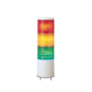
9.1.1 Signaling

Tower Lights
States  Lights |  | Aborting | Aborted | Clearing | Stopping | Stopped | Resetting | Idle | Starting | Execute | Holding | Held | Unholding | Suspending | Suspended | Unsuspending | Completing | Complete
Red | Fixed | ☐ | ☐ | ☐ | ☒ | ☒ | ☐ | ☐ | ☐ | ☐ | ☐ | ☐ | ☐ | ☐ | ☐ | ☐ | ☐ | ☐
Red | Flashing | ☒ | ☒ | ☒ | ☐ | ☐ | ☐ | ☐ | ☐ | ☐ | ☐ | ☐ | ☐ | ☐ | ☐ | ☐ | ☐ | ☐
Yellow | Fixed | ☐ | ☐ | ☐ | ☐ | ☐ | ☐ | ☐ | ☐ | ☐ | ☒ | ☒ | ☐ | ☐ | ☐ | ☐ | ☐ | ☐
Yellow | Flashing  | ☐ | ☐ | ☐ | ☐ | ☐ | ☐ | ☐ | ☐ | ☐ | ☐ | ☐ | ☐ | ☒ | ☒ | ☐ | ☐ | ☐
Green | Fixed | ☐ | ☐ | ☐ | ☐ | ☐ | ☐ | ☒ | ☐ | ☐ | ☐ | ☐ | ☒ | ☐ | ☐ | ☒ | ☐ | ☐
Green | Flashing | ☐ | ☐ | ☐ | ☐ | ☐ | ☐ | ☐ | ☒ | ☒ | ☐ | ☐ | ☐ | ☐ | ☐ | ☐ | ☒ | ☒

Operator station
States  Lights |  | Aborting | Aborted | Clearing | Stopping | Stopped | Resetting | Idle | Starting | Execute | Holding | Held | Unholding | Suspending | Suspended | Unsuspending | Completing | Complete
Red | Fixed | ☐ | ☐ | ☐ | ☒ | ☒ | ☐ | ☐ | ☐ | ☐ | ☐ | ☐ | ☐ | ☐ | ☐ | ☐ | ☐ | ☐
Red | Flashing | ☒ | ☒ | ☒ | ☐ | ☐ | ☐ | ☐ | ☐ | ☐ | ☐ | ☐ | ☐ | ☐ | ☐ | ☐ | ☐ | ☐
Blue | Fixed | ☐ | ☐ | ☐ | ☐ | ☐ | ☐ | ☐ | ☐ | ☐ | ☐ | ☐ | ☐ | ☐ | ☐ | ☐ | ☐ | ☐
Blue | Flashing | ☐ | ☐ | ☒ | ☐ | ☐ | ☐ | ☐ | ☐ | ☐ | ☐ | ☐ | ☐ | ☐ | ☐ | ☐ | ☐ | ☐
Green | Fixed | ☐ | ☐ | ☐ | ☐ | ☐ | ☐ | ☒ | ☐ | ☐ | ☐ | ☐ | ☒ | ☐ | ☐ | ☒ | ☐ | ☐
Green | Flashing | ☐ | ☐ | ☐ | ☐ | ☐ | ☐ | ☐ | ☒ | ☒ | ☐ | ☐ | ☐ | ☐ | ☐ | ☐ | ☒ | ☒

9.1.2 Operator Interface Panels

Screen map

Screen content
< Provide mockup of screen contents and purpose with emphasis on main elements contained within. >

9.3 Machine-to-Machine Interfaces

9.3.1 Physical interfaces
Physical inputs and outputs to exchange status between upstream and downstream machines.
Tag | Function | Direction | Signal Type | Signal Limits |  | Physical Limits
 |  |  |  | Lower | Upper | Lower | Upper
SpeedRef_AV | Speed reference from upstream machine | Input | Analog | 0V | 10V | 0 RPM | 100 RPM
SpeedRef_Fr | Speed reference from upstream machine | Input | Pulse train input frequency | 0Hz | 1000Hz | 0 RPM | 100 RPM
SpeedAct_AV | Actual speed for downstream machine | Output | Analog | 0V | 10V | 0 RPM | 100RPM

9.3.2 PackTags Interface
PackTags are data points that describe the condition of a machine in a standardized format. Data is categorized as Command, Status or Administration points. They are defined in the PackML standard ISA-TR88.00.02-2015 by OMAC. PackTags are composed of three components: Command, Status and Admin defined as subtypes PMLc, PMLs, PMLa.
See Appendix 2 for further details on structured type composition.
PackTags in bold are mandatory
Command - PMLc;
Command data produced by the 'Information Sender' (i.e. HMI, machine peers, etc.)
PackTag | Type | Description | Required
UnitMode | DINT | Numeric representation of the commanded unit mode | ☒
UnitModeChangeRequest | BOOL | Signals request that the current value of Command.UnitMode be activated | ☒
MachSpeed | REAL | Machine speed setpoint in units of [primary packages/min] | ☒
MaterialInterlock | ARRAY [1..32] OF BOOL | Bitwise indication that materials are ready for processing | ☐
CntrlCmd | DINT | Numerical representation of the state commands (1=Reset, 2=Start, etc.) | ☒
CmdChangeRequest | BOOL | Signals request that the current value of Command.CntrlCmd be activated | ☒
RemoteInterface | ARRAY[..] OF INTERFACE | Use to coordinate activities between peers (i.e. upstream or downstream unit machines.) | ☐
Parameter | ARRAY[..] OF DESCRIPTOR | Values or parameters associated to the end user supervisory interface. | ☐
Product | ARRAY[..] OF PRODUCT | Recipe or process data associated to the various products run on the unit machine. | ☐

Status - PMLs;
Status data produced for 'Information Sender' (i.e. HMI, machine peers, etc.)
PackTag | Type | Description | Required
UnitModeCurrent | DINT | Numeric representation of the active unit mode | ☒
UnitModeRequested | BOOL | Handshaking bit acknowledging that unit mode change request has been made. | ☐
UnitModeChangeInProcess | BOOL | Signals that unit mode change request has been accepted; switching is actively in process. | ☐
StateCurrent | DINT | Numeric representation of the active state | ☒
StateRequested | DINT | Handshaking value acknowledging that state change request has been made. | ☐
StateChangeInProcess | BOOL | Signals that state change request has been accepted; switching is actively in process. | ☐
MachSpeed | REAL | Active machine speed setpoint in units of [primary packages/min] | ☒
CurMachSpeed | REAL | Actual machine speed in units of [primary packages/min] | ☒
MaterialInterlock | ARRAY[0..31] OF BOOL | Bitwise indication that materials are ready for processing. | ☐
EquipmentInterlock | EQUIPMENTINTERLOCK | Signals that the machine is either blocked or starved | ☒
RemoteInterface | ARRAY[] OF INTERFACE | Use to coordinate activities between peers (i.e. upstream or downstream unit machines.) | ☐
Parameter | ARRAY[] OF DESCRIPTOR | Current values or parameters associated to the end user supervisory interface. | ☐
Product | ARRAY[] OF PRODUCT | Current recipe or process data associated to the various products run on the unit machine. | ☐

Administration - PMLa:
Administration data produced for higher level supervisory system.
PackTag | Type | Description | Required
Parameter | ARRAY[..] OF DESCRIPTOR | Parameters associated to the local interface (e.g. HMI) | ☐
Alarm | ARRAY[..] OF ALARM | Listing of all currently active alarms | ☐
AlarmExtent | DINT | Extent of the Alarm array | ☐
AlarmHistory | ARRAY[..] OF ALARM | Chronological alarm history, with most recent given as AlarmHistory[0] | ☐
AlarmHistoryExtent | DINT | Extent of AlarmHistory array | ☐
StopReason | ALARM | Alarm associated to the primary cause of machine stoppage ('first fault') | ☒
StopReasonExtent | DINT | Extent of StopReason | ☐
Warning | ARRAY[..] OF ALARM | Listing of all currently active warnings | ☐
WarningExtent | DINT |  | ☐
ModeCurrentTime | ARRAY[..] OF DINT | Elapsed time in seconds of current mode | ☐
ModeCumulativeTime | ARRAY[..] OF DINT | Cumulative time in seconds in each defined mode. | ☐
StateCurrentTime | ARRAY[..] OF DINT | Elapsed time in seconds of current [mode, state] pair. | ☐
StateCumulativeTime | ARRAY[..] OF DINT | Cumulative time in seconds in each defined [mode, state] pair. | ☐
ProdConsumedCount | ARRAY[..] OF COUNT | Count of raw materials used or consumed during production | ☐
ProdProcessedCount | ARRAY[..] OF COUNT | Count of total products (i.e. good + defective) made during production | ☒
ProdDefectiveCount | ARRAY[..] OF COUNT | Count of defective products made during production. | ☒
AccTimeSinceReset | DINT | Accumulative time since last reset of timer arrays. | ☐
MachDesignSpeed | REAL | Maximum design speed of the machine within given environment. | ☐
StatesDisabled | DINT | Bitwise indication of inactive states in current mode. | ☐
PLCDateTime | ARRAY [0..6] OF DINT | Current date and time of local processing unit (PLC, PC, PAC, microcontroller, etc.) | ☐

10. Reporting

<This section is used to capture the reporting needs, including but not limited to the scope and format of the report, data elements and contents required on the report, file types and extraction mechanisms, user base and accessibility levels, frequency of report extractions etc. Also provide the mockup of the report if needed. If necessary, create a separate document for reporting requirements.>

11. Definitions and Abbreviations

Term / Abbreviation | Description | Definition
Run Time |  | Time when the manufacturing process is scheduled and the machine is producing, including reduced speed and making reject parts.
Unplanned Stops |  | The manufacturing process is scheduled for production but is stopped due unforeseen events such as equipment failure or material shortage.
Planned Stops |  | The manufacturing process is scheduled for production and is not running because of a planned event such as a changeover.
Total Count |  | Total of all produced parts.
Cycle Time |  | Time to produce one part.
Run Rate |  | The production rate when actually producing. Inverse of cycle time.
HMI | Human Machine Interface | Component that enables humans to engage and interact with machines. Interaction is typically done via touch screen.
PackML | Packaging Machine Language | General specifications for packaging machine defined by Packaging Work Group in OMAC (Organization for Machine Automation and Control).
OMAC | Organization for Machine Automation and Control | OMAC is the organization for automation and manufacturing professionals that is dedicated to supporting the machine automation and operation needs of manufacturing.
ISA | International Society of Automation | ISA is a non-profit technical society for engineers, technicians, businesspeople, educators and students, who work, study or are interested in industrial automation and pursuits related to it.
EM | Equipment Module | Collection of control modules that can carry out specific tasks.
CM | Control Module | Collection of sensors or actuators that act as single entity from a control standpoint.
KPI | Key Point Indicator | Computable performance assessment, as derived from a combination of metrics.
Metrics |  | Quantifiable measure that is used to track and assess the status of a specific process.
OEE | Overall Equipment  Effectiveness | OEE measurement is commonly used as a key performance indicator (KPI) in conjunction with manufacturing efforts to provide an indicator of success.
OEM | Original Equipment  Manufacturer | OEM are manufacturing products or components bought by another company and sold under the purchasing company's brand or company name.

12. References

KB Controls website Article, PackML Essentials. https://www.kb-controls.io/post/packml-essentials

KB Controls website Article, How to Plan a PackML Compliant Machine. https://www.kb-controls.io/post/how-to-plan-a-packml-compliant-machine

Vorne website article, Calculate OEE. https://www.oee.com/calculating-oee.html
OMAC. PackML Unit/Machine Implementation Guide Part 1: PackML Interface Manager. V1.00. 2016
C. Bostrom, L. Smith, C. Nøkleby, M. Schluter, PackML Unit/Machine Implementation Guide, Part 2: Standard Representation of PackTags in an OPC UA Server, v1.01, 2018

13. Appendix

13.1 PackML Summary

PackML
PackML is a programming methodology that is organized around a state transition diagram. The PackML specification defines 17 states and the transitions from one state to another.

PackML Modes
A machine mode is a subset of states that define the machine’s operational mode. The most common modes are described in PackML. Additional modes, such as Changover, can be added. The described modes in PackML include:
- Production Mode, the machine executes normal production logic in response to commands coming from external systems or the machine operator.
- Maintenance Mode, authorized personnel can run the machine independently of other systems. This mode is used for troubleshooting, machine trials, or testing operational improvements
- Manual Mode, authorized personnel can directly control single machine modules. This mode is used for commissioning single components and fault diagnosis.

Mode Transitions States
Mode transition states are states where the machine is permitted to change states. This machine follows PackML best practices states that change of modes should occur in one of the stable machine states: Idle, Stopped, Aborted.
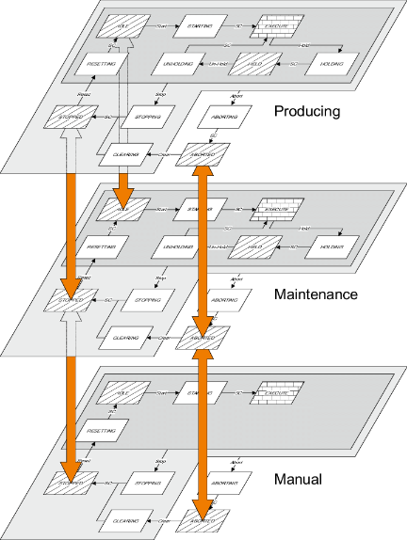

PackML Machine States
The PackML state machine model contains 17 pre-defined states and pre-defined transitions between those states. Specific logic is executed in the different states. Not all states need to be used for each mode, however the Idle, Execute, Stopped and Aborted states are mandatory. 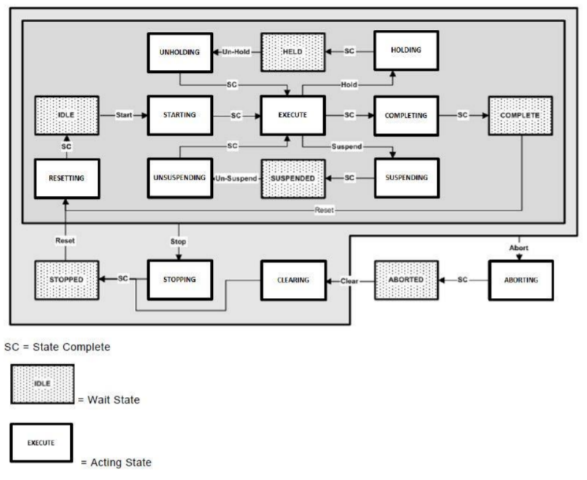

13.2 PackML Base Structure Data Types
ISA-TR88.00.02-2015 defines 7 base structure data types that are required to build the complete set of PackTags.

13.2.1 Alarm
The alarm type contains information required to describe an individual alarm or warning.
Tag | Type | Description
Trigger | BOOL | Alarm or warning current status
ID | DINT | Alarm or warning identification number
Value | DINT | Context specific value associated to given alarm or warning
Message | STRING | Alarm or warning description
Category | DINT | Identification number associated to alarm type or severity
DateTime | ARRAY[0..6] OF DINT | Time stamp of alarm or warning occurrence. Format year:month:day:hour:min:sec:μsec
AckDateTime | ARRAY[0..6] OF DINT | Time stamp of alarm or warning acknowledgment. Format year:month:day:hour:min:sec:μsec

13.2.2 Count
The count type contains information required to track the number of occurrences of a given operation. The operation itself may also be described.
Tag | Type | Description
ID | DINT | Product identification number
Name | STRING | Product description
Unit | STRING | Product unit of measure
Count | DINT | Count since last operator reset
AccCount | DINT | Count since last accumulative counter reset

13.2.3 Descriptor
The descriptor type is used to describe parameters in the unit/machine.
Tag | Type | Description
ID | DINT | Parameter identification number
Name | STRING | Parameter description
Unit | STRING | Parameter unit of measure
Value | REAL | Numeric value of parameter

13.2.4 EquipmentInterlock
The descriptor type is used to describe parameters in the unit/machine.
Tag | Type | Description
Blocked | BOOL | Machine stoppage due to downstream fault
Starved | BOOL | Machine stoppage due to upstream or supply fault

13.2.5 Ingredient
The ingredient type comprises the collection of tags required to describe the raw materials used in a given product recipe.
Tag | Type | Description
IngredientID | DINT | Ingredient identification number
Parameter | ARRAY[..] OF DESCRIPTOR | Parameters associated to given ingredient

13.2.6 Interface
The interface type includes data used to coordinate state machine transitions between machines. Parameter information may also be exchanged.
Tag | Type | Description
Number | DINT | Identification number of upstream or downstream unit machine
Name | DINT | Parameter description
ControlCmdNumber | DINT | Control command for upstream or downstream machine
CmdValue | DINT | Control command value associated with ControlCmdNumber
Parameter | ARRAY[..] OF DESCRIPTOR | Parameter data required for peer-to-peer coordination

13.2.7 Product
The product type comprises all tags required to make a given product. This includes process-specific data, as well as all recipe data.
Tag | Type | Description
ProductID | DINT | Product identification number
ProcessVariables | ARRAY[..] OF DESCRIPTOR | Parameters required for processing given product
Ingredients | ARRAY[..] OF INGREDIENT | Ingredients required for processing given product

